Authentication - Sign up

Bug ID : BUG001

Bug Title : Text fields accept numerical values instead of restricting to alphabets only

Description:
On the Sign-Up page, text fields such as Full Name, District, and Occupation accept numerical input (e.g., “1234” or “abc123”) without showing any validation message. These fields are intended for alphabetic input only, but currently allow users to enter numbers and submit the form. This behavior leads to invalid data entries and impacts data quality. Proper input validation should be implemented to restrict these fields to alphabetic characters only.

Steps To Reproduce:
- Navigate to the https://staging-lms-qa.bdpl.com.np/sign-up
- Click on the “Sign Up” button.
- Enter numerical numbers on Full Name, District and Occupation field (e.g., “0000000000000” or “#$%$^”)
- Observe that the field accepts the input.
- Click Register

Expected Result:
The Full Name, District, and Occupation fields should only accept alphabetic characters (A–Z) and display a validation message if numeric or special characters are entered.

Actual Result:
The Full Name, District, and Occupation fields accept numeric input without displaying any validation message.

Screencast:
https://jam.dev/c/97b12594-39ca-426d-a776-e0d3a5a5b30e

Enhancement Issue
Bug ID : BUG002

Bug Title : Field label and validation message colors are too similar, causing confusion

Description:
On the Sign-Up page, the field label is displayed in orange, and the validation message appears in red. However, the two colors look very similar, which makes it difficult for users to visually distinguish between the label and the validation error. This can lead to confusion, especially for users with color perception difficulties.

Steps To Reproduce:
- Navigate to https://staging-lms-qa.bdpl.com.np/sign-up
- Click on the “Sign Up” button.
- Leave the Full Name field empty or enter invalid input.
- Observe the label and validation message colors.

Expected Result:
The validation message should be clearly distinguishable from the field label through a contrasting color

Actual Result:
The field label (orange) and validation message (red) look visually similar, making it difficult for users to differentiate between them.

Screenshot:
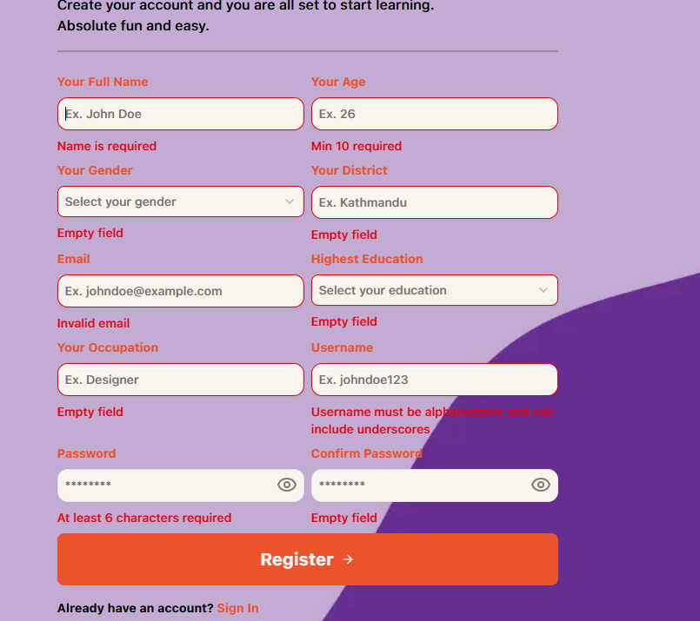

Bug ID : BUG003

Bug Title : Age field allows entering negative numbers (validation occurs only after submission)

Description:
In the Sign-Up form, the Age field allows users to enter negative values (e.g., -1). The system shows a validation error only after the user submits the form. Ideally, the field should restrict negative input immediately (client-side validation) to improve user experience.

Steps To Reproduce:
- Navigate to the https://staging-lms-qa.bdpl.com.np/sign-up
- Click on the “Sign Up” button.
- In the Age field, type -1.
- Observe that the field accepts the input.
- Click Register

Expected Result:
The Age field should prevent users from entering negative numbers

Actual Result:
The Age field accepts negative input, and validation occurs only upon form submission.

Screencast:
https://jam.dev/c/557253d4-439e-456b-8520-ba3365f26987

Bug ID : BUG004

Bug Title : Full Name overflows in verification email when excessively long input is entered

Description:
The Full Name field on the Sign-Up form does not enforce a maximum length. Users can enter an extremely long string (numbers, characters, etc.), and when the verification email is sent, the oversized name overflows or breaks the email layout.

Steps To Reproduce:
- Navigate to https://staging-lms-qa.bdpl.com.np/sign-up.
- Enter a very long string (e.g., hundreds or thousands of characters/digits) in the Full Name field.
- Complete the rest of the form and submit.
- Check the verification email sent to the registered address.
- Observe that the Full Name text overflows or breaks the email layout.

Expected Result:
- Full Name should enforce a maximum length (e.g., 100 characters).
- Validation error should appear if input exceeds the allowed length and prevent form submission.
- The verification email should display the Full Name correctly without overflowing, even if the input reaches the maximum allowed length.

Actual Result:
- The Full Name field accepts unlimited input.
- Verification email displays the name overflowing or breaking the layout.

Screenshot:
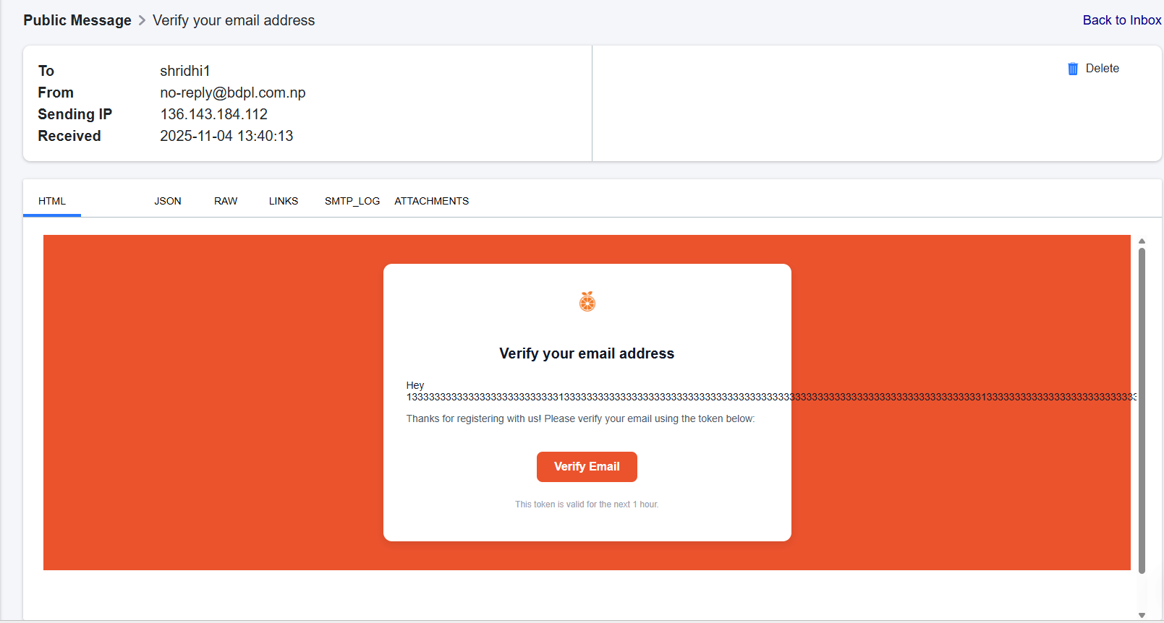
Temporary mail shridhi1@mailinator is used
Bug ID : BUG005

Bug Title : Sign-Up form incorrectly combines email and username validation errors

Description:
On the Sign-Up page, when a user attempts to register using either an already registered email with a new username, or an already registered username with a new email, the system incorrectly displays the error message: “User with the same email and username already exists.”

This message is misleading because in these cases only one of the fields is already in use. The validation logic should check the email and username independently and display accurate messages, but currently it combines the two, confusing users and negatively impacting the registration experience.

Steps To Reproduce:
- Navigate to https://staging-lms-qa.bdpl.com.np/sign-up.
- Enter an already registered email with a new username and click Submit.
- Observe the error message.
- Enter a new email with an already registered username and click Submit.
- Observe the error message again.

Expected Result:
The Validation messages should clearly indicate which field is already in use:
Only email exists → “Email already registered.”
Only username exists → “Username already taken.”
The system should not incorrectly combine the fields in the message.

Actual Result:
The system always displays:
“User with the same email and username already exists,”
even when only one of the fields is already registered.

Screencast:

User with registered Email and unregistered username
https://jam.dev/c/1a9896c0-bd5b-4808-97f6-c1f918404639

User with unregistered Email and registered username
https://jam.dev/c/553e6a51-6f0a-405c-a46b-a8b0ab7c46e5

Bug ID : BUG006

Bug Title : Sign-Up allows duplicate accounts when email case differs

Description:
The Sign-Up form does not treat email addresses as case-insensitive. When a user tries to register using an already registered email in uppercase or mixed case, the system allows the registration, sends a new verification link, and treats it as a completely new account. Email addresses should be case-insensitive according to standard email rules, and the system should prevent duplicate accounts regardless of letter casing.

Steps To Reproduce:
- Navigate to https://staging-lms-qa.bdpl.com.np/sign-up.
- Enter an email address that is already registered, but in uppercase or mixed case (e.g., AASMA@MAILINATOR.COM).
- Fill other required fields and click Submit.
- Observe that the system accepts the email and sends a verification link.

Expected Result:
The system should treat email addresses as case-insensitive. If an email is already registered, entering the same email in uppercase, lowercase, or mixed case should display a validation message:
“Email is already registered.”

Actual Result:
When an already registered email is entered in uppercase or mixed case, the system allows registration, sends a new verification email, and treats it as a separate account.

Screencast:
https://jam.dev/c/31fdfcab-89e5-446f-b5dc-09ca85746a55

Bug ID : BUG007

Bug Title : Username field does not enforce alphanumeric validation

Description:
On the Sign-Up page, the username field displays a validation message stating:
“Username must be alphanumeric.”
However, this validation is not enforced. Users can enter non-alphanumeric usernames such as [123456, test,] without any error message. The validation message only appears when the field is left empty. This leads to inconsistent behavior and allows invalid usernames to be submitted, potentially affecting data consistency.

Steps To Reproduce:
- Navigate to https://staging-lms-qa.bdpl.com.np/sign-up.
- Enter a username such as 123456 or Test
- Fill other required fields and click Submit.
- Observe that no validation message appears.
- Leave the username field empty and click Submit → the message “Username must be alphanumeric” appears.

Expected Result:
The username field should enforce alphanumeric validation in real-time and upon submission. Any input containing non-alphanumeric characters should trigger the message:
“Username must be alphanumeric.”
Users should not be able to submit the form with invalid usernames.

Actual Result:
Users can enter numeric-only (123456), alphabetic-only (Test), or other invalid usernames, and the system does not display any validation message. The validation message only appears if the field is left empty.

Screencast:
https://jam.dev/c/599346e1-cfd1-461c-886b-90f7098dfb9a

Home-Page

Bug ID : BUG008

Bug Title : Home page does not clearly reflect logged-in state after user login

Description:
After logging in, the home page URL remains the same as the public view (/) and only subtle profile elements indicate that the user is logged in. This can confuse users and affects automation testing, as scripts cannot reliably detect whether the user is logged in based on URL or visible page content.

Steps To Reproduce:
- Navigate to https://staging-lms-qa.bdpl.com.np/
- Click Login and enter valid credentials.
- Submit the login form.

Expected Result:
After logging in, the user should either be redirected to a dedicated dashboard/home page or the home page content should update clearly to reflect the logged-in state, making it obvious the user is logged in.

Actual Result:
After logging in, the URL remains https://staging-lms-qa.bdpl.com.np/ and the page layout appears mostly identical to the logged-out view; only the username/profile dropdown indicates the user is logged in.

Impact:
It affects user experience and automation testing, as test scripts cannot reliably detect the logged-in state based on URL or page content alone.

Screenshot:
https://jam.dev/c/c16df565-ce85-455e-a396-434592bddff7

Bug ID : BUG009

Bug Title : Navigating to the Contract page reloads and displays the previously visited page

Description:
When attempting to navigate to the Contract page from other pages (such as Courses or Privacy Policy), the system refreshes the page but does not load the Contract content. Instead, it reloads and displays the previously visited page, such as the Courses or Privacy Policy page, even though the user clicked on Contract. This gives the impression that the Contract page is either broken or incorrectly linked, disrupting the user flow.

Steps To Reproduce:
- Log in to https://staging-lms-qa.bdpl.com.np/.
- Navigate to the Courses page.
- Click on the Contract link in the navigation.
- Observe that the page refreshes but remains on the Courses page.
- Repeat the same steps from the Privacy Policy page and observe the same issue

Expected Result:
Clicking on the Contract link should correctly load and display the Contract page content with the proper URL (/contract)

Actual Result:
After clicking Contract, the system reloads and displays the previously visited page (e.g., Courses or Privacy Policy) instead of the Contract page.

Screencast:
https://jam.dev/c/a855c9d6-5a1e-4c9c-8160-b6ac46b8abc3

Bug ID : BUG010

Bug Title : Social media icons have broken links — redirect to previously visited page instead of opening target pages

Description:
When clicking on social media icons such as Facebook, Instagram, or YouTube in the footer, the system refreshes but displays the previously visited page instead of opening the respective social media pages.

Steps To Reproduce:
- Navigate to https://staging-lms-qa.bdpl.com.np/.
- Scroll to the footer section.
- Click on any social media icon (Facebook, Instagram, YouTube).
- Observe that it reloads the previous page instead of opening the social media site.

Expected Result:
Each social media icon should open its correct external link (Facebook, Instagram, or YouTube) in a new tab.

Actual Result:
Clicking any social media icon refreshes the current page and shows the previously visited page instead of redirecting to the social media platform.

Screencast:
https://jam.dev/c/abd5383a-be99-4b39-9e88-063c2906778d

Courses
Feature Request
Bug ID : BUG011

Bug Title : Enforce serial course progression for lessons

Description:
Courses are intended to be completed sequentially, meaning a user must finish earlier lessons before accessing subsequent ones. Currently, in the Example: Introduction to QA course, users can directly access lessons 1.3 or 1.4 without completing 1.1 and 1.2, bypassing the intended learning sequence. This may result in missing critical foundational knowledge.

Steps To Reproduce:
- Navigate to Courses.
- Select Introduction to QA.
- Click directly on lessons 1.3 or 1.4 without completing 1.1 and 1.2.
- Observe that lessons are accessible even though prior lessons are incomplete.

Expected Result:
Users should be required to complete lessons in order. For example, in the Introduction to QA course, a user must complete Lesson 1.1 and 1.2 before accessing 1.3 or 1.4. Any attempt to access a lesson out of sequence should display a clear message, such as “Please complete previous lessons to unlock this lesson,” and prevent the user from opening that lesson until prior lessons are finished.

Actual Result:
Currently, users can freely navigate to any lesson within a course regardless of whether previous lessons have been completed. Lessons such as 1.3 and 1.4 are accessible even if 1.1 and 1.2 are incomplete, allowing users to skip foundational content and bypass the intended sequential learning workflow.

Screencast:
https://jam.dev/c/440d1046-c654-454d-afd6-b776679a895c

Profile

Bug ID : BUG012

Bug Title : Age field in Edit Profile accepts invalid long numeric values and shows incorrect error message

Description:
When navigating to the Edit Profile page via the Profile option under the username menu, entering a long numeric value in the Your Age field does not trigger any validation message. Unlike the sign-up form, where such inputs are restricted, the Edit Profile form accepts them without validation. Upon clicking Update Changes, the system displays a generic “Something went wrong” error message instead of a proper validation message.

Steps To Reproduce:
- Log in to https://staging-lms-qa.bdpl.com.np/.
- Click on your username in the header and select Profile.
In the Edit Profile form, enter a long numeric value in the Your Age field (e.g., 9999999999).
- Click Update Changes.
- Observe that no validation message appears, and the system shows “Something went wrong.”
Expected Result:
The Your Age field in the Edit Profile form should validate inputs similarly to the sign-up form restricting invalid or unrealistic numeric values and displaying a clear validation message (e.g., “Please enter a valid age”). The system should not show a generic error after submission.

Actual Result:
The Edit Profile form allows entering long numeric values in the Age field without any validation. After clicking Update Changes, the system shows a “Something went wrong” error message instead of an age validation error.

Screencast:
https://jam.dev/c/7a74510f-a18d-463a-ae64-4a2a5b7dbd74

Change Password

Bug ID : BUG013

Bug Title : Cannot log in after changing password; server-side error occurs

Description:
After a user changes their password via the Change Password option and logs out, attempting to log back in using the new password triggers an error due to a server-side issue. Users cannot access their accounts even with valid credentials, indicating a problem in the server handling of password updates or authentication.

Steps To Reproduce:
- Log in to https://staging-lms-qa.bdpl.com.np/.
- Click on your username in the header and select Change Password
- Change Password
- Observe that no validation message appears, and the system shows “Something went wrong.

Expected Result:
After successfully changing the password, the user should be able to log in immediately with the new password without errors.

Actual Result:
Attempting to log in with the new password after a change results in a server-side error that prevents access to the account.

Screencast:
502

